**RECRUITMENT SYSTEM**

1. SRIKAR APPANI - 21BD1A660A

2. B MONISH - 21BD1A660D

3. ISHA JAIN - 21BD1A660V

4. K BHAVANA - 21BD1A660Z

5. MANVITHA CH - 21BD1A6617

6. P MANASVI - 21BD1A661G

**Problem Statement :** Development of Recruitment system.

The Recruitment System provides online help to the users all over the world. Earlier recruitment was done manually and it was a time-consuming activity. Now it is possible in a fraction of second. The development of the system has been designed to do a whole lot more than just reduce paperwork. It can make a significant contribution to a company's marketing and sales activities, since ultimately the employees hired, work on the final product or service that defines the profit-loss trajectory of a company. An efficient recruitment system makes it possible for managers to access information that is crucial to managing their staff, which they can use for human resources management, staffing and planning activities, and much more.

Our proposed website aims to simplify the recruitment process. The system has facilities where prospective candidates can upload their CV and apply for jobs suited to them. It also makes it possible for organizations to post their staffing requirements and view profiles of interested candidates.

The project efficiently addresses the critical challenge of assembling a skilled and cohesive team. A well-designed recruitment system streamlines the hiring process, enabling organizations to identify and hire the most qualified individuals promptly.

This system not only helps in mitigating project delays due to staffing gaps but also ensures that the team possesses the diverse skill sets and collaborative spirit necessary to tackle complex software development challenges effectively. Furthermore, it promotes a structured approach to workforce planning, aligning recruitment efforts with project goals and timelines, ultimately enhancing the overall project's chances of success.

**Software Requirement Specification**

**For RECRUITMENT SYSTEM**

**Version 1.0 approved**

**Prepared by:**

1. **Srikar Appani - 21BD1A660Z**

**2. B Monish - 21BD1A660D**

**3. Isha Jain - 21BD1A660V**

**4. K Bhavana - 21BD1A660Z**

**5. Manvitha CH - 21BD1A660N**

**6. P Manasvi - 21BD1A661H**

**Keshav Memorial Institute of Technology**

**19-09-2023**

**Table of Contents**

**1.Introduction**..........................................................................................................................

1.1 Purpose........................................................................................................

1.2 DocumentConventions................................................................................

1.3 Intended Audience and Reading Suggestions...........................................

1.4 Product Scope............................................................................................

1.5 References.................................................................................................

## **2.Overall Description**

2.1 Product Perspective…………………………………………………………….....

2.2 Product Functions………………………………………………………………....

2.3 Operating Environment…………………………………………………………...

2.4 User Characteristics……………………………………………………………….

2.5 Design and Implementation Constraints…………………………………………

2.6 User documentation………………………………………………………………...

2.7 Assumptions and Dependencies………………………………………………....

## 

## **3.Specific Requirements**

3.1 Functional Requirements………………………………………………………….

3.2 Non-Functional Requirements…………………………………………

**4. Appendix Diagram**

4.1 Use Case Diagram

4.2 Use Case Template

4.3 Sequence And Collaboration Diagram

4.4 Class Diagram

4.5 State Chart Diagram

4.6 Activity Diagram

4.7 Package Diagram

4.8 Component Diagram

4.9 Deployment Diagram

**1.** **Introduction:**

## **1.1** **Purpose**

The primary purpose to develop this system is to optimize the recruitment process for an organization. Our project deals with recruitment processes involved in the software engineering domain. The website shows the recruitment process of a candidate. We thus make the entire recruitment process user friendly and easy to implement.

## **1.2 Document Conventions**

## **Heading:**

Font-Size:16

Font-Style: Bold

Font: Times New Roman

**Subheading**:

Font-Size:14

Font-Style: Bold

Font: Times New Roman

**Content:**

Font-Size:12

Font: Times New Roman

## 

## 

## 

## **1.3** **Intended Audience and Reading Suggestions**

## This document serves as a prototype for the Recruitment System, and it offers valuable insights to a diverse range of stakeholders. Developers can utilize it as a blueprint to create and implement the system effectively. Companies can utilize this system to sort applicants based on their qualifications and company requirements, speeding the process and efficiency while maintaining a structured approach to workforce planning.

## **1.4 Product Scope**

Our multi-platform solution enables users to have the typical recruitment facilities at their disposal. Our primary objective is to reduce the workload involved in the recruitment process making it easier for the companies to hire employees since the recruitment process is online. The proposed website structure in this paper focuses mainly on the Computer Science and Engineering domain, however other domains can be explored as well using the same structure.

**1.5 References:**

* <https://www.slideshare.net/krupalshah1/employee-recruitment-system-srs>
* <https://www.scribd.com/doc/237022826/SRS-for-Online-Campus-Recruitment-System>

# 

# **2.** **Software Requirements**

**2.1 Functional Requirements:**

Functional requirement defines a function of a [system](https://en.wikipedia.org/wiki/System) or its component, where a function is described as a specification of behavior between outputs and inputs.

Functional requirements may involve calculations, technical details, data manipulation and processing, and other specific functionality that define what a system is supposed to accomplish.Behavioral requirements describe all the cases where the system uses the functional requirements, these are captured in [use cases](https://en.wikipedia.org/wiki/Use_case).

**2.1.1 Administrator:**

Requirement ID : RI.01.01

Title : Database Management

Description : Control the entire database containing records of customers and

Employee details. If there is any problem in the database(whether it is for

Accessing or updating) will be solved as soon as possible without delay.

Priority : 2

Requirement ID : RI.01.02

Title : Contact and giving permission to company

Description: : Contact with the company and give permission to use the site for recruitment purposes.

Priority : 1

Requirement ID : RI.01.03

Title : View all details

Description : Able to view the details of all users and control the whole site.

Priority : 3

**2.1.2 Applicant :**

Requirement ID : R1.02.01

Title : Registration

Description : New users should sign up by creating login credentials.

Priority : 1

Requirement ID : R1.02.02

Title : Login

Description : Applicants must have a valid credentials (registered at the time of registration)to enter into the site.

Priority : 1

Requirement ID : R1.02.03

Title : Enter details

Description : Need to fill required information about self and upload CV.

Priority : 2

**2.1.3 Employer** :

Requirement ID : R1.03.01

Title : Taking permission from administrator.

Description : Company must take permission from the Administrator to use the site.

Priority : 1

Requirement ID : R1.03.02

Title : View details.

Description : Can view all details filled by applicants and their CV.

Priority : 2

Requirement ID : R1.03.03

Title : Shortlisting most suitable candidates.

Description : Can view the top-most candidates for further evaluation in the interview process.

Priority : 3

**2.2 Non-Functional Requirements:**

Nonfunctional Requirements (NFRs) define system attributes such as security, reliability, performance, maintainability, scalability, and usability. They serve as constraints or restrictions on the design of the system across the different backlogs. Also known as system qualities, nonfunctional requirements are just as critical as functional Epics, Capabilities, Features, and Stories. They ensure the usability and effectiveness of the entire system. Failing to meet any one of them can result in systems that fail to satisfy internal business, user, or market needs, or that do not fulfill mandatory requirements imposed by regulatory or standards agencies.

**2.2.1 Performance Requirements and Compatibility**

● The system will be able to accommodate several applicants for various companies without any fault.

● It will also be compatible in various browsers.

**2.2.2 Safety Requirements and Usability**

**●** System use shall not cause any harm to human users.

**●** The UI of the website is user-friendly.

**2.2.3 Security Requirements**

**●** System will use a secured database.

**●**  Once submitted, the applicant can’t edit details.

**●** The employer can only view the submitted details of applicants.

● Login credentials ensure a more secure access of information.

**2.2.4 Error handling**

● The website shall handle expected and unexpected errors in ways that prevent loss in information and long downtime period.

**3. Diagrams**

**3.1 Use-Case Diagram:**

A use case diagram is a visual representation in Unified Modeling Language (UML) that depicts the interactions between a system and its external entities, known as actors, to showcase the various ways the system can be utilized. It provides a high-level overview of the system's functionality by illustrating the different scenarios or use cases in which actors interact with the system to achieve specific goals.

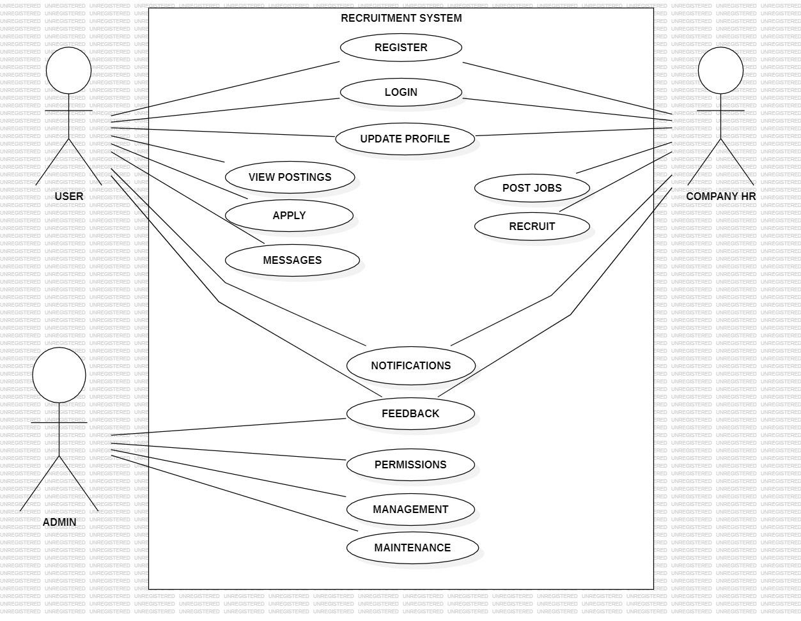

**3.2 Activity Diagram:**

An activity diagram in Unified Modeling Language (UML) is a behavioral diagram that illustrates the flow of activities within a system, showcasing the sequence of actions or steps involved in a process. It provides a dynamic view of a system's functionality, emphasizing the order and dependencies of activities to model the workflow and decision points in a clear and comprehensible manner.

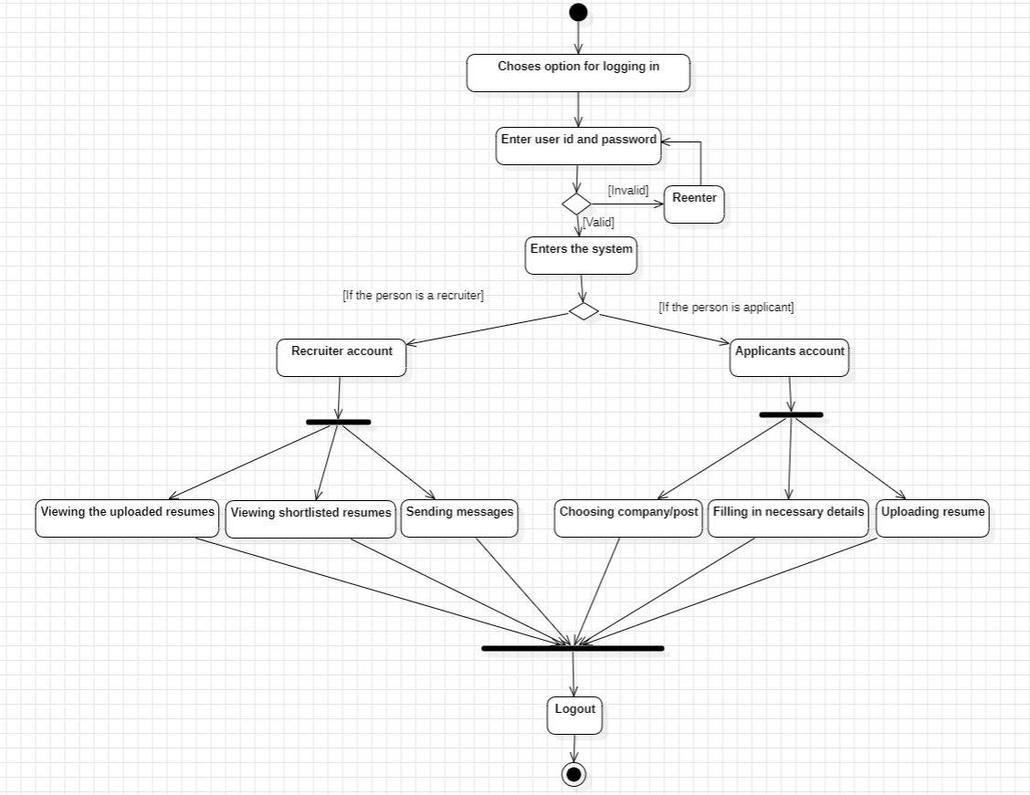

**3.3 Sequence Diagram:**

A sequence diagram in Unified Modeling Language (UML) represents the interactions and order of messages exchanged between objects or components in a system over time. It provides a dynamic visualization of the runtime behavior, emphasizing the chronological sequence of events and the communication flow between various elements within the system.

APPLICANT BASED: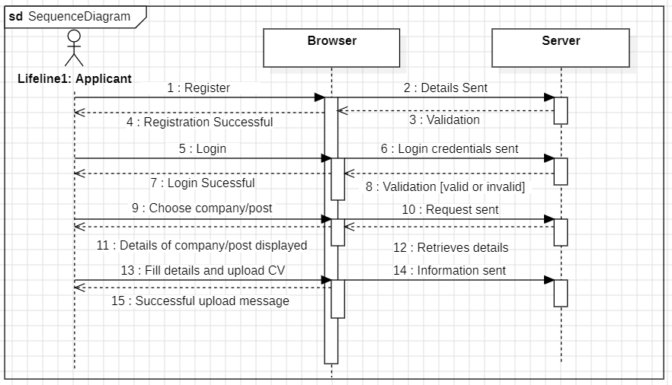

RECRUITER OR EMPLOYER BASED:

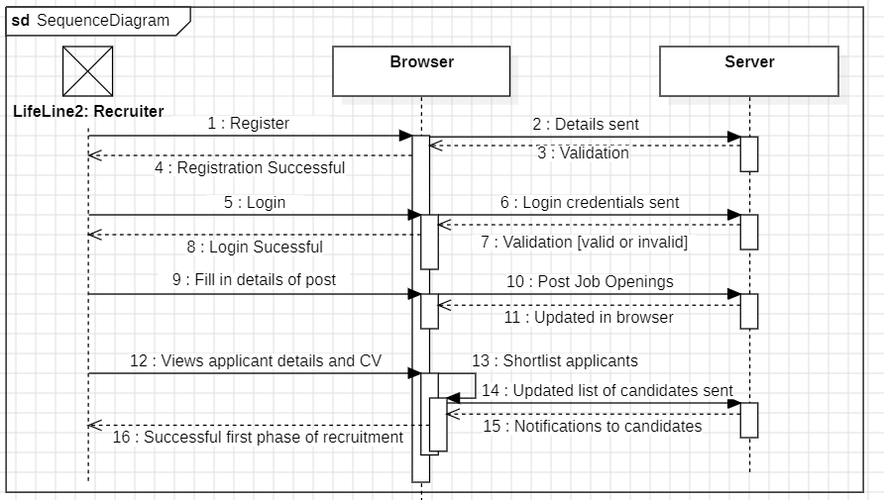

**3.4 Class Diagram**

**3.4 Class Diagram:**

A class diagram in Unified Modeling Language (UML) represents the static structure of a system by illustrating the classes, their attributes, and the relationships between them. It visually conveys the blueprint of the system's object-oriented design, detailing the key entities, their properties, and the associations among classes.

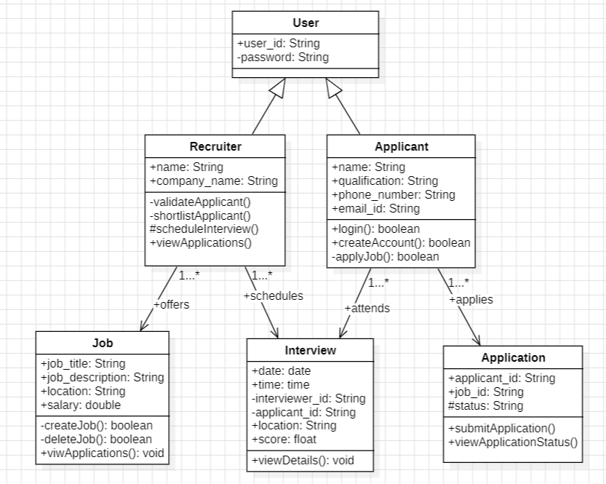

**3.5 Component Diagram:**

The component diagram's main purpose is to show the structural relationships between the components of a system. It is represented by a boxed figure.

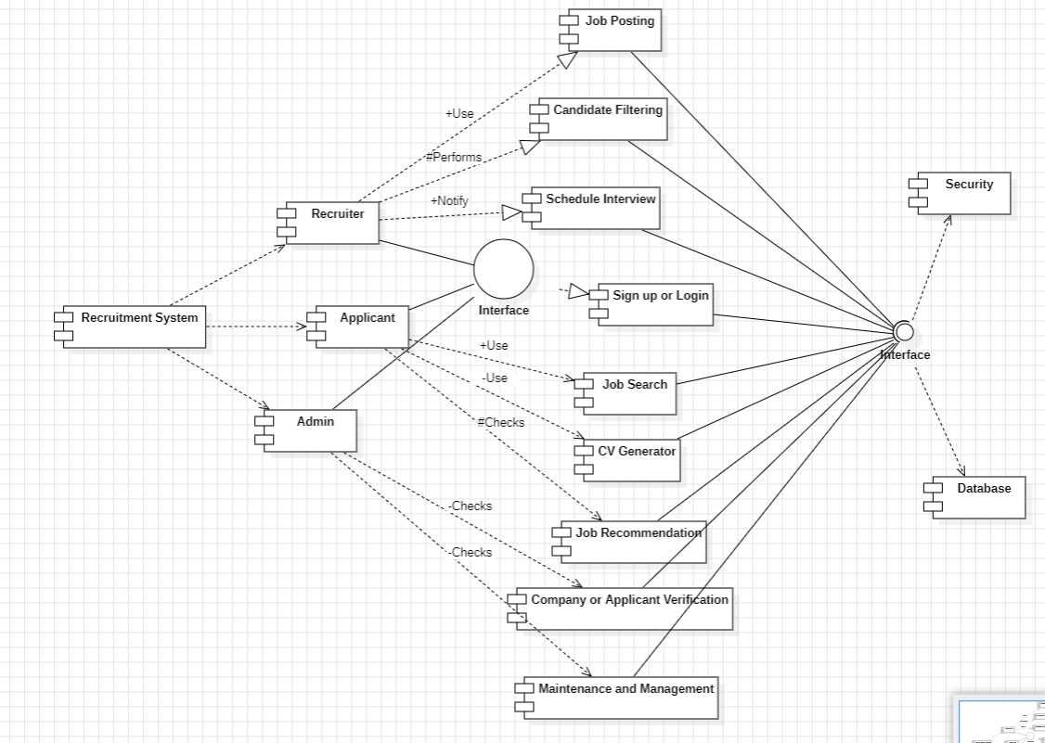

**FORMS:**

Form 1:

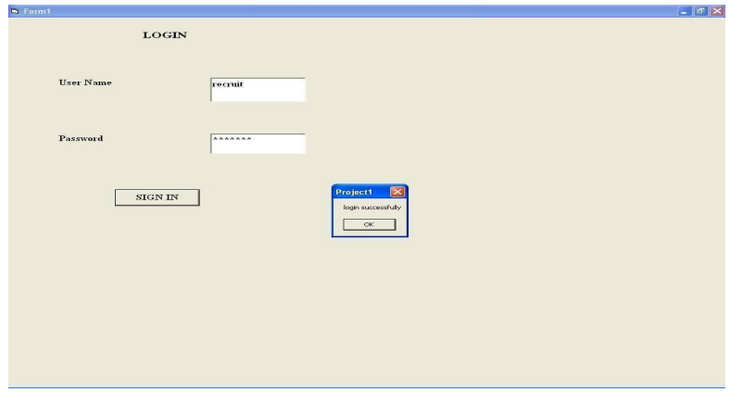

Form 2:

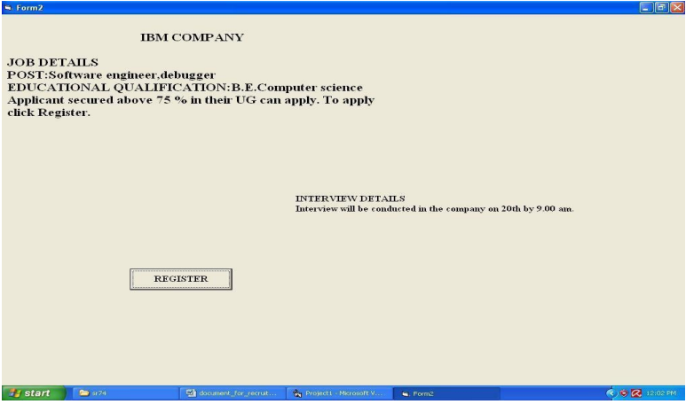

Form 3:

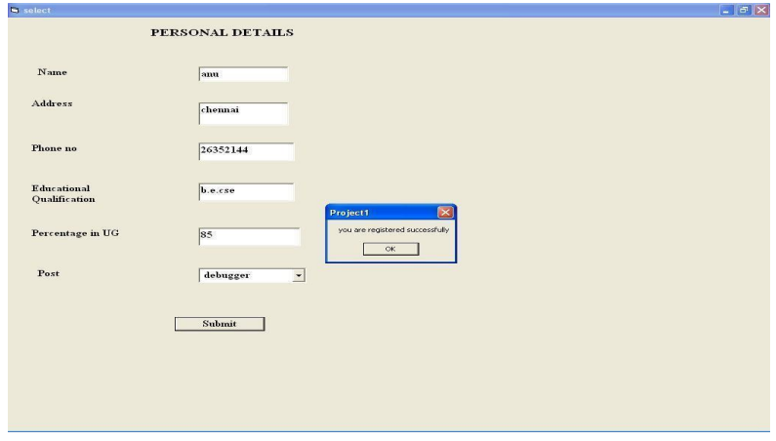

Form 4:

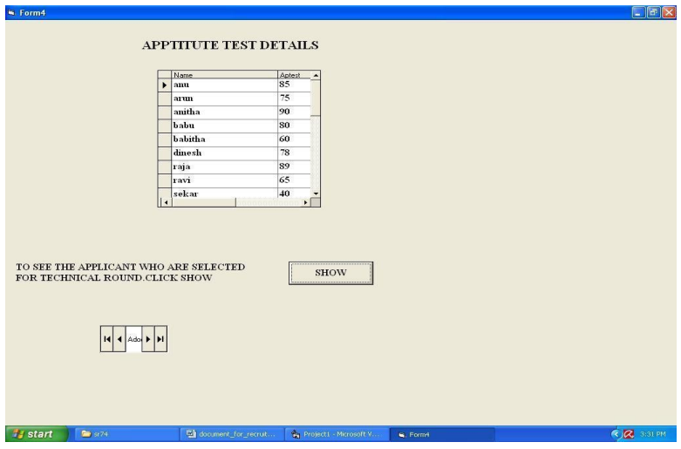

Form 5:

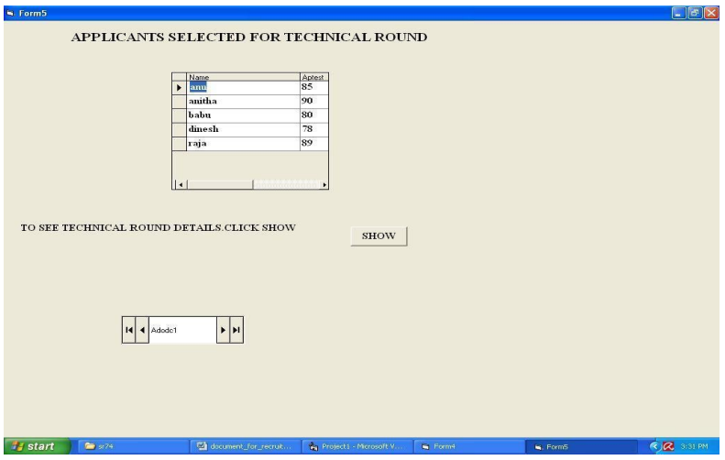

Form 6:

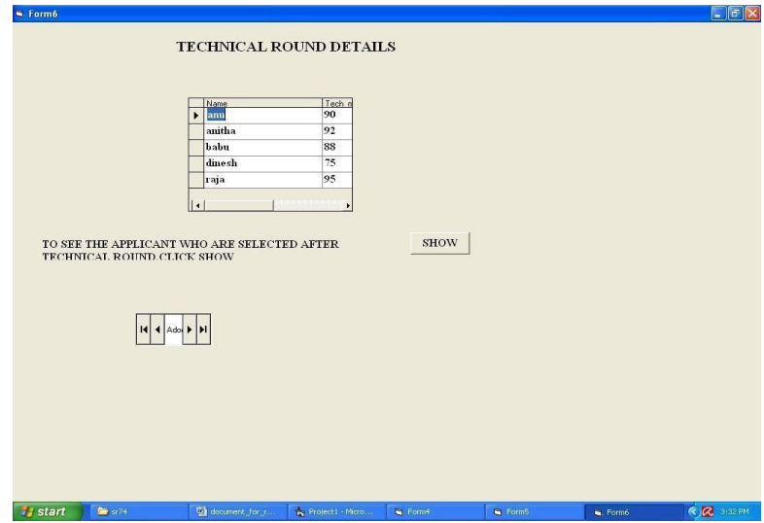

Form 7: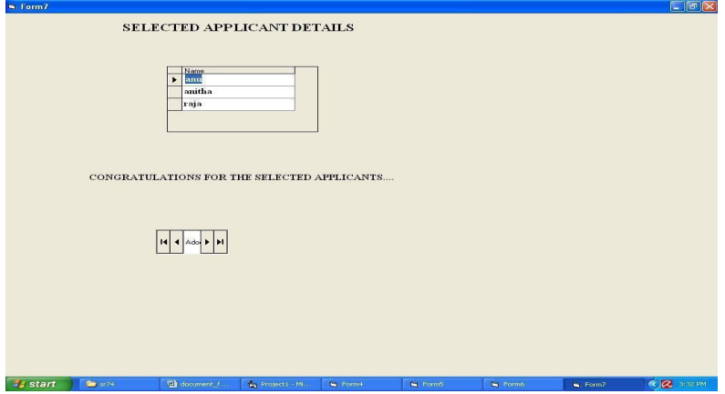

Form 8:

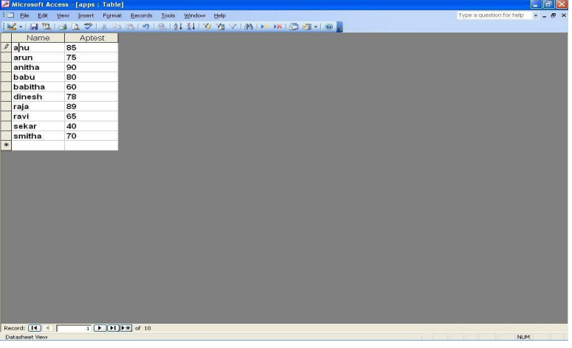

**RESULT:** Thus the project to develop an online recruitment system is done successfully.